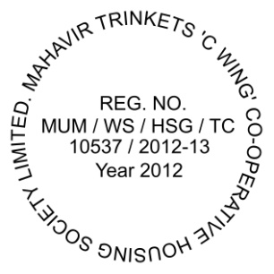
Form ‘I’
[See Rules 32 and 65{1}]
REGISTER OF MEMBERS
[Section 38(1) of the Maharashtra Co-operative Societies Act, 1960]

1 | Serial Number e.g., 01 (See J Form) | Click here to enter text.
2 | Date of admission # | 20 November 2012
3 | Date of payment of entrance fee | 21 August 2011
4 | Full name (CAPITAL LETTERS) | Click here to enter text.
5 | Address (Flat No) e.g.: 0805 – 0806 | Click here to enter text.
6 | Occupation | Click here to enter text.
7 | Age on the date of admission #  e.g.: 55 Years 05 Months 05 Days | Click here to enter text.
8 | Full name and address of the person nominated by the member under Section 30(1) | Click here to enter text.
9 | Date of nomination | Click here to enter a date.
10 | Date of cessation of membership
11 | Reasons for cessation
12 | Remarks

Date | Cash book folio | Particulars of shares held |  |  |  | Total amount received  Rs. Ps. | No. of shares held | Share Certificate  Numbers  e.g., 0001 - 0010 (See J Form)
Date | Cash book folio | Application  Rs. Ps | Allotment | Amount received on |  | Total amount received  Rs. Ps. | No. of shares held | Share Certificate  Numbers  e.g., 0001 - 0010 (See J Form)
 |  |  |  | 1st call | 2nd call | Total amount received  Rs. Ps. | No. of shares held | Share Certificate  Numbers  e.g., 0001 - 0010 (See J Form)
# | NA | 500.00 | 10 | - | - | 500.00 | 10 | Click here to enter text.

PARTICULARS OF SHARES TRANSFERRED OR SURRENDERED

Date | Cash Book Folio | Cash Book Folio Or Share Transfer Reg. No | No. of Shares | Serial No.  of Share Certificates | No. of Shares Transferred  or Refunded | Balances |  | Total Amount Received  Rs. Ps.
 |  |  |  |  |  | No. of shares held | Share Certificate  Numbers | Total Amount Received  Rs. Ps.

